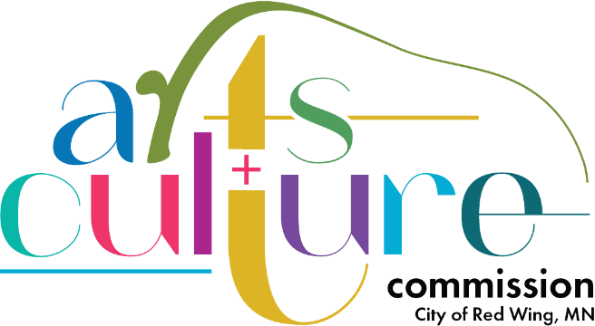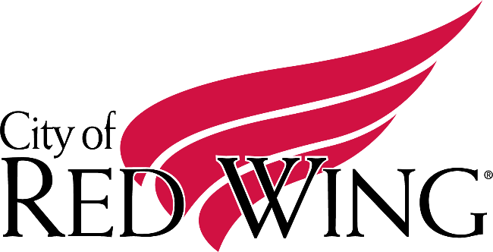

**Arts & Culture Commission Committees 2024**

Executive Committee – Zamira Mendoza, Katie Nolan, Melissa Hill

Finance Committee – Zamira Mendoza, Emily Guida Foos

Marketing Committee – Stephanie Rogers, Alyssa Riegelman

Public Art Committee – Katie Nolan, Cliff Emery, Gary Stone, David Culver